CO456 Web Development

Using the ‘intweb’ server

Modified from notes of (Richard Mather, 2021)

You will require a suitable text editor, secure ftp program and a web browser. Suggested that you use TextPad, Notepad++, Sublime Text or similar (MS Notepad is limited on script and file handling features) to write your scripts / html.

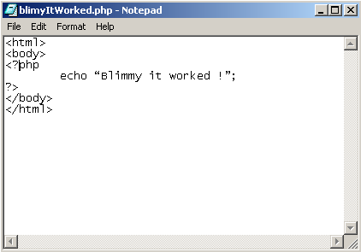

If using MS Notepad, when you save the file ensure you select AllFiles within the save as type combo box and give your file an appropriate extension e.g. *.php – for php script files; *.html – for pure html file

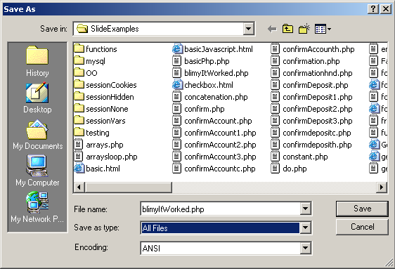

Failure to select AllFiles will result in .txt being appended to the file name. The server would not recognise this as an html/php/kml etc. file and consequently would not be able to find it.

It is advised that you save all your scripts within an appropriate directory on your G: area or USB storage device before copying them onto the server.

You will need access to a secure ftp program, in order to copy the files from your local G:\ to the web server. Many options are available … FileZilla (Mozilla), Core FTP Lite from or WinSCP.

WinSCP

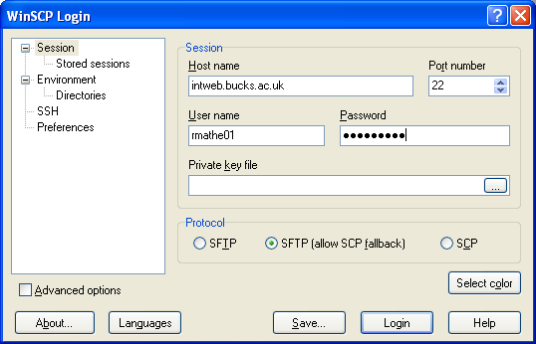

The connection dialogue boxes above (or similar) will be displayed automatically on starting the Core program.

Enter the following (depending on which FTP app’ used)

A description of the connection

The Host name which in our case will be intweb.bucks.ac.uk

Your Unix login

Your Unix password

Check the SSH/SFTP checkbox and ensure all the others are unchecked.

Now click the connect button.

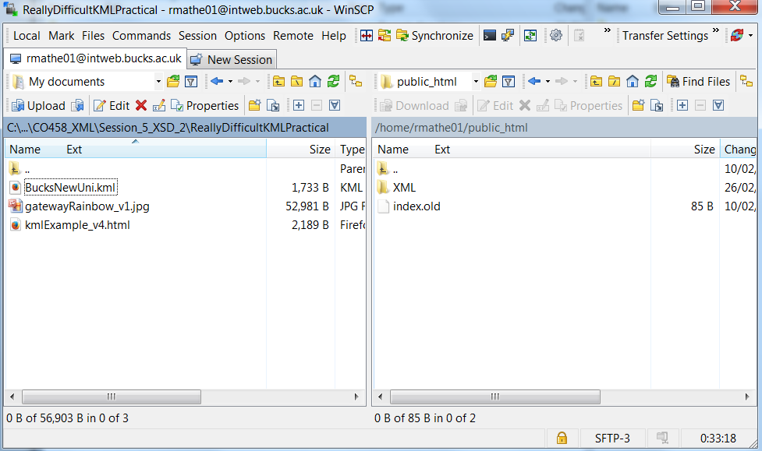

The directory tree on the left is your local drive and the one on the right is your home directory on the server. Any script or html files that you write should be saved within the public_html directory or a sub directory within it. To move into the public_html directory - double click it and to move back to your home directory double click the <…> icon. Within public_html you can create directories by clicking the Make Directory button.

To copy files from your local drive into the public_html directory

1. Ensure you are inside the public_html directory
2. Select the file on your local / G:
3. Click the button with the blue arrow pointing right or drag and drop files.

The html scripts you place on the server may be accessed using your Web Browser. To so this type the following address into the browsers address box

http://intweb.bucks.ac.uk/~myUnixLogin

Substitute your user name (student ID) for myUnixLogin but do not forget to include the ~ symbol.

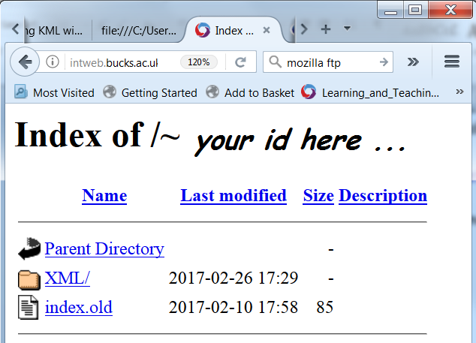

When you press the enter key, either index.html will be presented, or, if you rename index.html to index.old (or similar) a list of the files within the public_html directory will be displayed instead. Simply click on one of the files to run it. If the file is in a sub directory, click on the sub directory to display its contents.